Promoting High-Quality Development of the Heat Pump Industry: 2025 China Heat Pump Forum Successfully Held

The 2025 China Heat Pump Forum (CHPF) had the theme of "Promoting High-Quality Development of the Heat Pump Industry and Assisting in the Green Transformation of Economy and Society". The conference was grandly held in Jinan, China, from July 29 to 31, hosted by the China Heat Pump Alliance (CHPA).
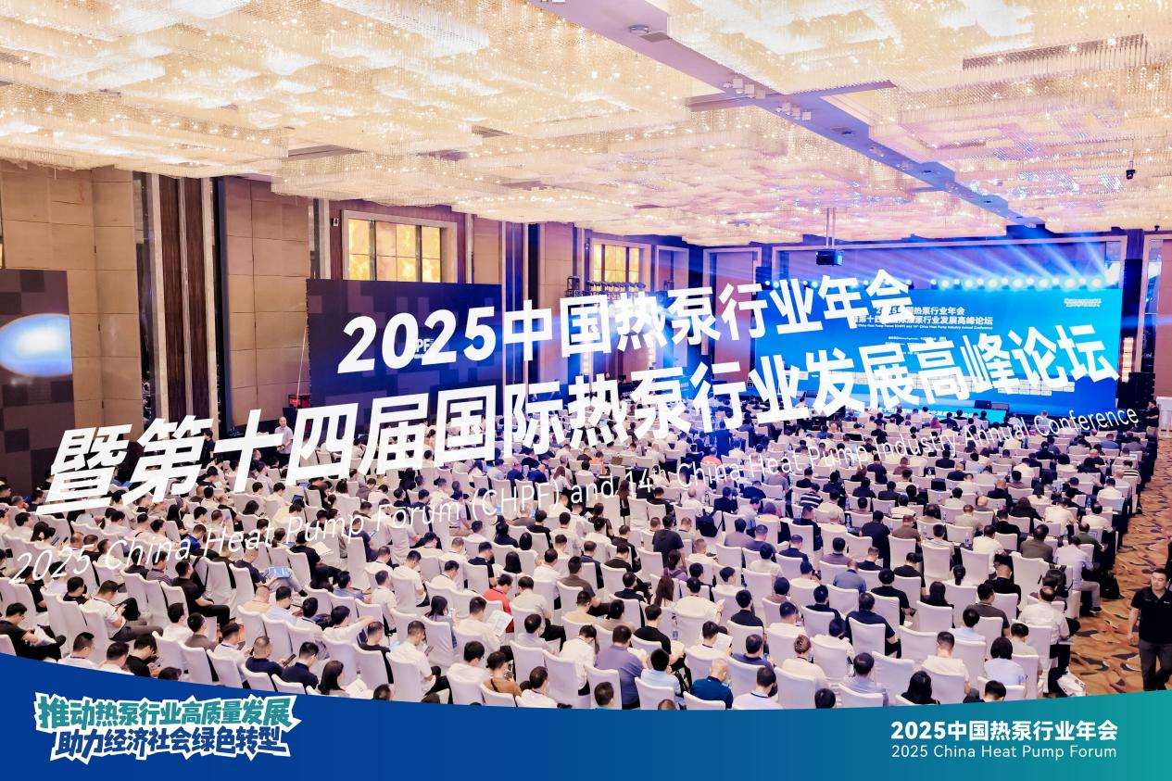
2025 CHPF covers numerous fields of heat pump industry development and technological applications. It included seventeen sub-forums and exchange meetings, such as the High-Quality Development Forum of the Heat Pump Industry, the Chief Engineer Forum on Heat Pump Technology Application, the Forum on Heat Pumps Assisting in the Construction of Zero-Carbon Factories and Parks, the Development Forum of Heat Pump Comfort Systems, the Forum on Heat Pumps Promoting Low-Carbon Development of District Heating, the Forum on Clean Heating and Channel Growth of Heat Pumps, the International Policy and Market Development Forum of Heat Pumps, the Technical Innovation Forum for Improving Heat Pump Energy Efficiency, the Technical Innovation and Development Forum of High-Temperature Heat Pumps, the Multi-Energy Complementary Technology Forum of Heat Pumps, and the Industrial Application Development Forum of Heat Pumps.
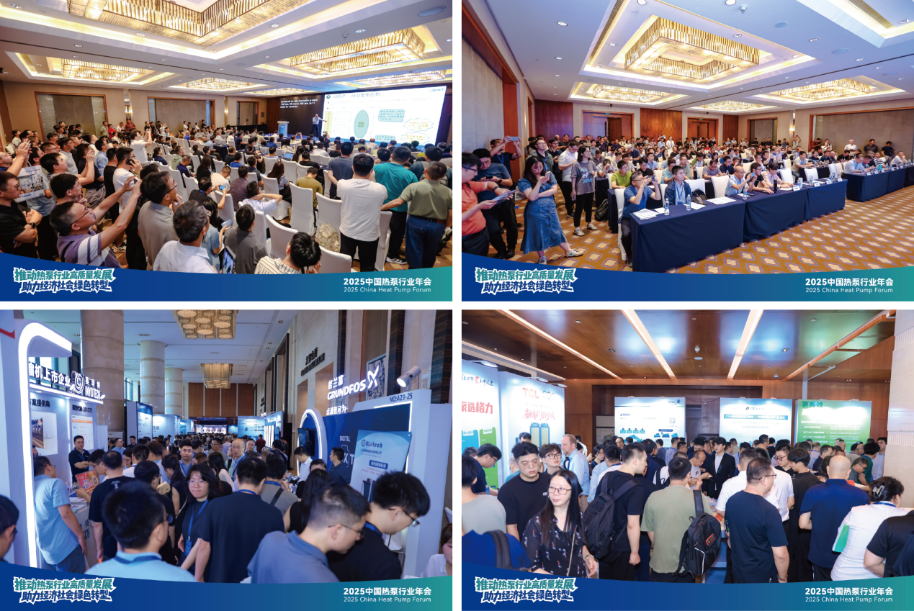
Peixue Jiang, the renowned professor in the field of HP and Vice President of Tsinghua University, delivered a speech at the conference. He pointed out that promoting the high-quality development of the heat pump industry is conducive to advancing energy conservation and carbon reduction in key areas, as well as fostering new growth points in green and low-carbon industries. He also put forward four hopes for the Heat Pump Professional Committee of China Energy Conservation Association and the entire heat pump industry: first, promote collaborative innovation among industry, academia, research, and application; second, strengthen product promotion and technology popularization; third, carry out vocational skills training; fourth, deepen international cooperation in the heat pump field.

During the conference, several professional research reports were released, including "Industrial Heat Pump Development White Paper (2025)", "Global Heat Pump Industry Development Report (2025)", "2025 China Heat Pump Industry Development Report", "White Paper on Market and Technology Development of Heat Pump for air-coning and floorh heating system (2025)", "Zero-Carbon Industry", and "Air-Source Heat Pump Heating Technology". A series of industry activities was also held, including the High-Quality Heat Pump Procurement and Exhibition, the Heat Pump System Application Design Competition, the Excellent Paper Award, the Friendly Football Match, the Photography Competition on Heat Pumps Assisting Green and Low-Carbon Development, and the Industry Dinner.
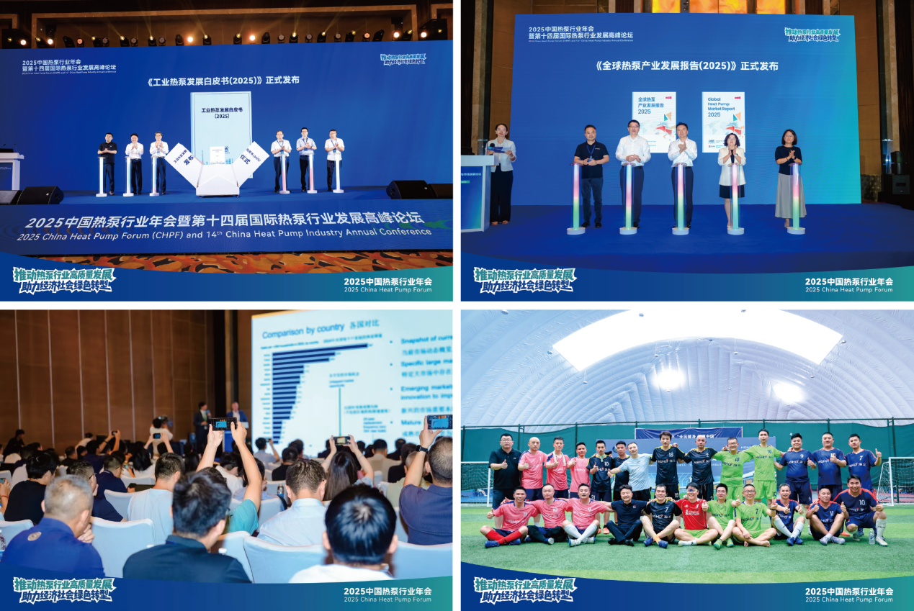
The successful holding of the 2025 CHPF played an essential role in actively promoting the implementation of policies such as the "Action Plan for Promoting High-Quality Development of the Heat Pump Industry", and advancing technological progress, quality improvement, and influence expansion of the heat pump industry.

